Ideation Phase

Define the Problem Statements

Date | 31 January 2026
Team ID | LTVIP2026TMIDS24384
Project Name | iRevolution: A Data-driven Exploration of  Apple's iPhone Impact in India using Tableau
Maximum Marks | 2 Marks

Customer Problem Statement Template:
Create a problem statement to understand your customer's point of view. The Customer Problem Statement template helps you focus on what matters to create experiences people will love.
A well-articulated customer problem statement allows you and your team to find the ideal solution for the challenges your customers face. Throughout the process, you’ll also be able to empathize with your customers, which helps you better understand how they perceive your product or service.
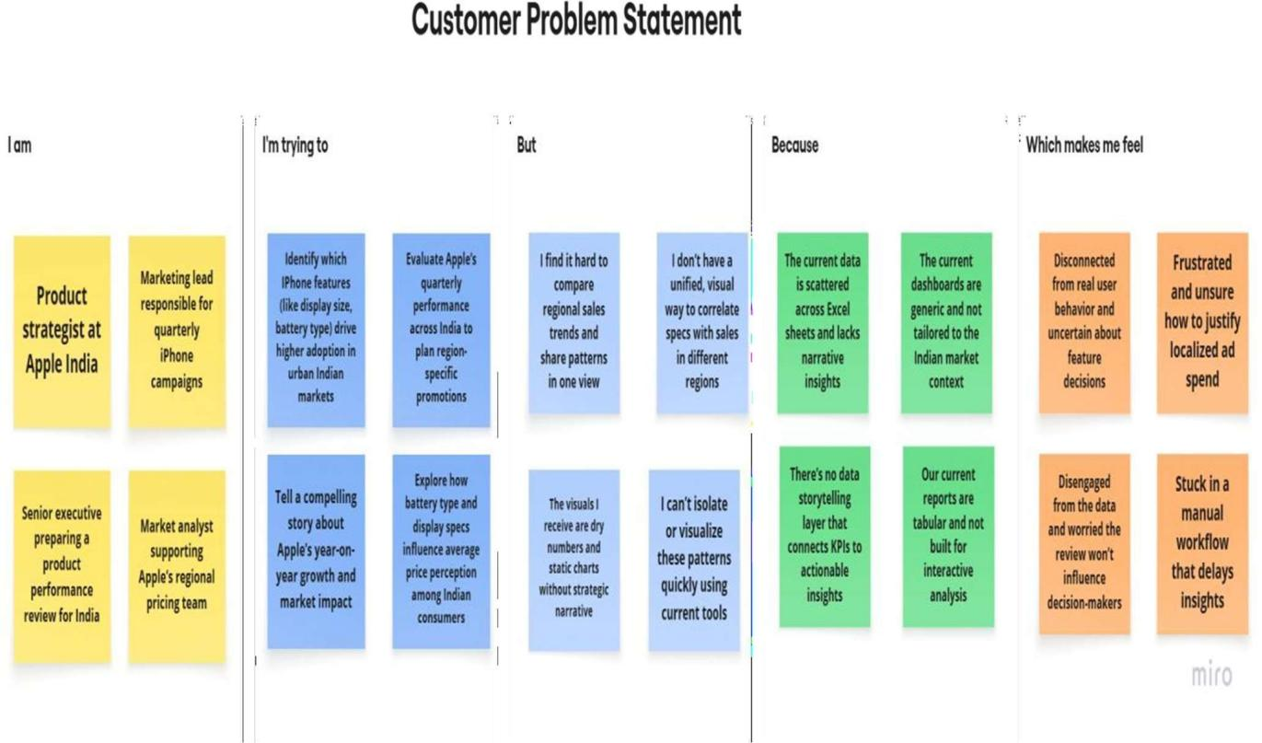

Problem Statement (PS) | I am | I’m trying to | But | Because | Which makes  me feel
PS-1 | a product strategist | find which iPhone features drive adoption in urban India | data is scattered and not visual | there's no unified dashboard | unsure about feature decisions
PS-2 | a marketing lead | track regional performance for iPhone campaigns | I can’t compare trends across quarters and states | dashboards aren’t  India-specific | frustrated and uncertain on promotions
PS-3 | Senior executive | present iPhone growth in India clearly | reports lack storytelling and visual appeal | there’s no narrative-driven dashboard | disenga ged and ineffecti ve
PS-4 | market analyst | link features like battery/display to price | I can’t visualize  patterns easily | tools are static and not interactive | slowed down and stuck

